Notice of The Norfolk County Council (Surface Dressing - South Area)
Temporary Traffic Regulation Order 2026
Section 14(1) of the Road Traffic Regulation Act 1984 (RTRA 1984)

Norfolk County Council proposes to make the Surface Dressing - South Area Temporary Traffic Regulation Order (the “Order”) (STRO14449) to facilitate surface dressing works affecting:
- A1065 Castle Acre Road from its junction with the B1145 Lynn Road to its junction with the U33279 Bailey Street (“Road A”)
- A1065 Road From Swaffham To Weasenham All Saints from its junction with the B1145 Lynn Road to its junction with the U33279 Bailey Street (“Road B”)
- B1108 Hingham Road / Norwich Road / Watton Road from its junction with the U71430 Ironside Way to its junction with the C166 Low Road (“Road C”)
- B1135 Crownthorpe Road from its junction with the U78209 Wicklewood Road to its junction with the C166 Wymondham Road (“Road D”)
- B1172 London Road from its junction with the C572 London Road to its junction with the U78284 Eleven Mile Lane (“Road E”)
- B1172 Station Road from its junction with the B1172 London Road to its junction with the U78285 Chepore Lane (“Road F”)
- C489 Main Road from its junction with the C888 Mowles Road to its junction with the C489 Fox Lane (“Road G”)
- B1077 Attleborough Road from its junction with the C135 The Street to its junction with the U33143 Bow Street (“Road H”)
- B1077 Buckenham Road from its junction with the U33090 Burgh Common to its junction with the U33083 Fen Street (“Road I”)
- B1077 Attleborough Road from its junction with the U33090 Burgh Common to its junction with the U33083 Fen Street (“Road J”)
- B1077 Haugh Road from its junction with the B1113 Castle Hill Road to its junction with the B1134 Heath Road (“Road K”)
- B1113 The Turnpike from its junction with the C350 Upgate Street to its junction with the C351 Rode Lane (“Road L”)
- B1146 Draytonhall Lane from its junction with the C470 Dereham Road to its junction with the A47 Dereham Bypass (“Road M”)
- A1075 Shipdham Road, South Green from its junction with the U31169 Rash’s Green to its junction with the U35150 Stone Road (“Road N”)
- B1172 London Road from its junction with the U78325 Preston Avenue to its junction with the C594 Station Road (“Road O”)
- B1527 Hempnall Road from its junction with the A140 Norwich Road to its junction with the C204 Alborough Road (“Road P”)
- B1527 Mill Road from its junction with the A140 Norwich Road to its junction with the C204 Alborough Road (“Road Q”)
- B1527 Bungay Road from its junction with the A140 Norwich Road to its junction with the C204 Alborough Road (“Road R”)
- B1113 Norwich Road from its junction with the C346 Long Stratton Road to its junction with the U76095 Hurn Lane (“Road S”)
- B1332 Norwich Road from its junction with the C187 Shotesham Road to its junction with the C203 The Street (“Road T”)
- B1332 Norwich Road from its junction with the C368 Church Road to its junction with the U76389 Church Road (“Road U”)
- A143 Yarmouth Road from its junction with the C533 Wardley Hill Road to its junction with the A146 Norwich Road (“Road V”)
- A1074 Dereham Road from its junction with the A47 Longwater interchange to its junction with the C162 Longwater Lane (“Road W”)
- A1074 Dereham Road from its junction with the A47 Longwater interchange to its junction with the C162 Longwater Lane (“Road X”)
- A1075 Thetford Road, Memorial Way from its junction with the B1108 Watton Road to its junction with the C402 Jessup Road (“Road Y”)
- A1066 Hurth Way from its junction with the A1075 Norwich Road to its junction with the A1066 Thetford Road (“Road Z”)
- C171 Norwich Road from its junction with the A1075 Norwich Road to its junction with the A1066 Thetford Road (“Road AA”)
- C171 / C162 West End from its junction with the C461 Taverham Lane to its junction with the C162 The Street (“Road BB”) and
- C162 The Street from its junction with the C171 Town House Road to its junction with the A1067 Drayton High Road (“Road CC”)
The Roads A–CC will be temporarily closed/restricted (except for pedestrian access) for the duration of the works/period the closure is necessary which is anticipated to be on:
- Roads A and B between 05:00 – 16:00 on the 17th May 2026 and between 19:00 and 05:00 on the 30th April and 1st June 2026;
- Road C between 19:00 – 05:00 on the 18th May, 8th and 22nd June 2026;
- Road D between 19:00 – 05:00 on the 20th May, 9th and 24th June 2026;
- Roads E and F between 19:00 – 05:00 on the 26th May 2026;
- Road G between 19:00 – 05:00 on the 22nd May, 3rd and 15th June 2026;
- Road H between 19:00 – 05:00 on the 1st June, 10th and 25th June 2026;
- Roads I and J between 19:00 – 05:00 on the 2nd and 26th June 2026 and 18:00 – 00:00 on the 13th June 2026;
- Road K between 19:00 – 05:00 on the 3rd, 15th and 30th June 2026;
- Road L between 19:00 – 05:00 on the 4th and 16th June and 1st July 2026;
- Road M between 19:00 – 23:00 on the 4th June and 19:00 – 00:00 on the 23rd June 2026;
- Road N between 19:00 – 23:00 on the 5th June and 19:00 – 00:00 on the 23rd June 2026;
- Road O between 19:00 – 00:00 on the 18th and 19th July 2026;
- Roads P, Q and R between 17:00 – 05:00 on the 7th June and 5th July 2026 and between 17:00 – 23:00 on the 21st June 2026;
- Road S between 19:00 - 23:00 on the 9th and 17th June and 2nd July 2026;
- Road T between 19:00 – 05:00 on the 10th and 23rd June and 7th July 2026;
- Road U between 19:00 – 05:00 on the 11th and 24th June and 8th July 2026;
- Road V between 19:00 – 05:00 on the 14th, 15th and 25th June and 10th July 2026;
- Roads W and X between 18:30 – 05:00 on the 21st June, 17:30 – 00:00 on the 28th June and 19:00 – 05:00 on the 11th July 2026;
- Road Y between 17:30 – 23:00 on the 21st and 28th June 2026;
- Road Z between 19:00 - 05:00 on the 20th June and 1st July 2026;
- Road AA between 19:00 – 00:00 on the 28th June and 2nd July 2026;
- Road BB between 08:00 – 15:00 on the 28th July 2026; and
- Road CC between 08:00 – 15:00 on the 2nd August 2026 and 09:00 – 16:00 on the 10th August 2026
but may continue to be closed/restricted until the 30th September 2026 where the closure/restriction are still required beyond the anticipated dates.
Alternative routes will be displayed on site.
The works promoter for this restriction/closure is: Norfolk County Council
Vehicular access will be permitted to a final destination in the Roads A–CC where signs indicating such access is possible and permitted are in place.
The Order shall automatically revoke on the completion of the works/when the closures are no longer necessary or otherwise on the 30th September 2026 without further notice.
If necessary, the restrictions could run for a maximum period of 18 months from the date the Order is effective.
A person who contravenes, or who uses or permits the use of a vehicle in contravention of the restriction/closures imposed by the Order shall be guilty of an offence.
Penalty: £1000 maximum fine on conviction and/or endorsement for contravention.
In the event of the start dates being delayed the new start date will be displayed on site in advance.
Full details on the closures are available on the OneCauseway website at https://one.network. Any enquiries that cannot be answered on the one.network website should be directed to the South Area Streetworks (Infrastructure Department) contactable by telephone at 0344 800 8020 or email at streetworks@norfolk.gov.uk
Dated this 17th day of April 2026

Katrina Hulatt
Director of Legal Services (nplaw)
County Hall
Martineau Lane
Norwich
NR1 2DH

Road A, A1065 Castle Acre Road and

Road B, A1065 Road From Swaffham To Weasenham All Saints
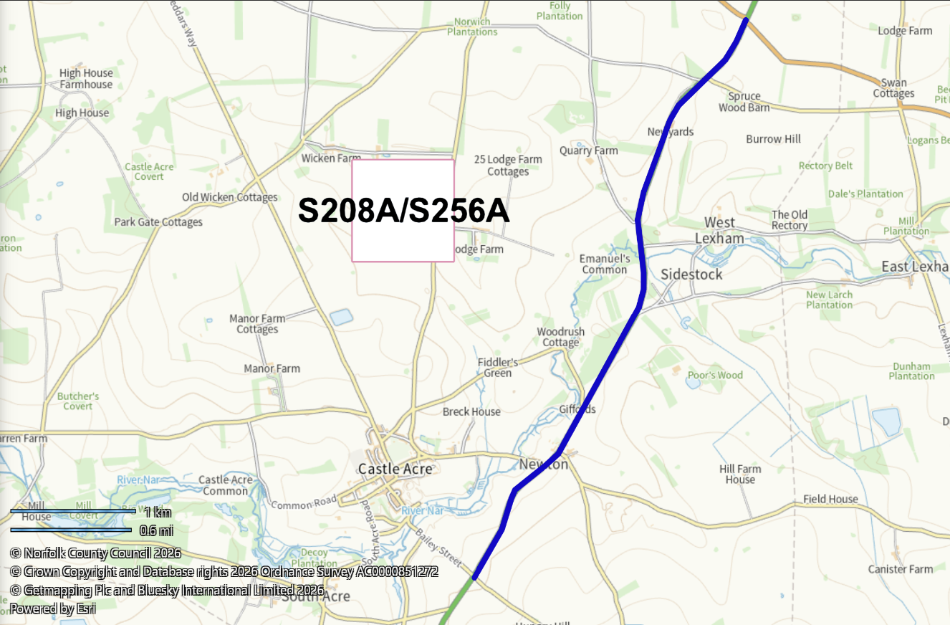

Road C, B1108 Hingham Road / Norwich Road / Watton Road
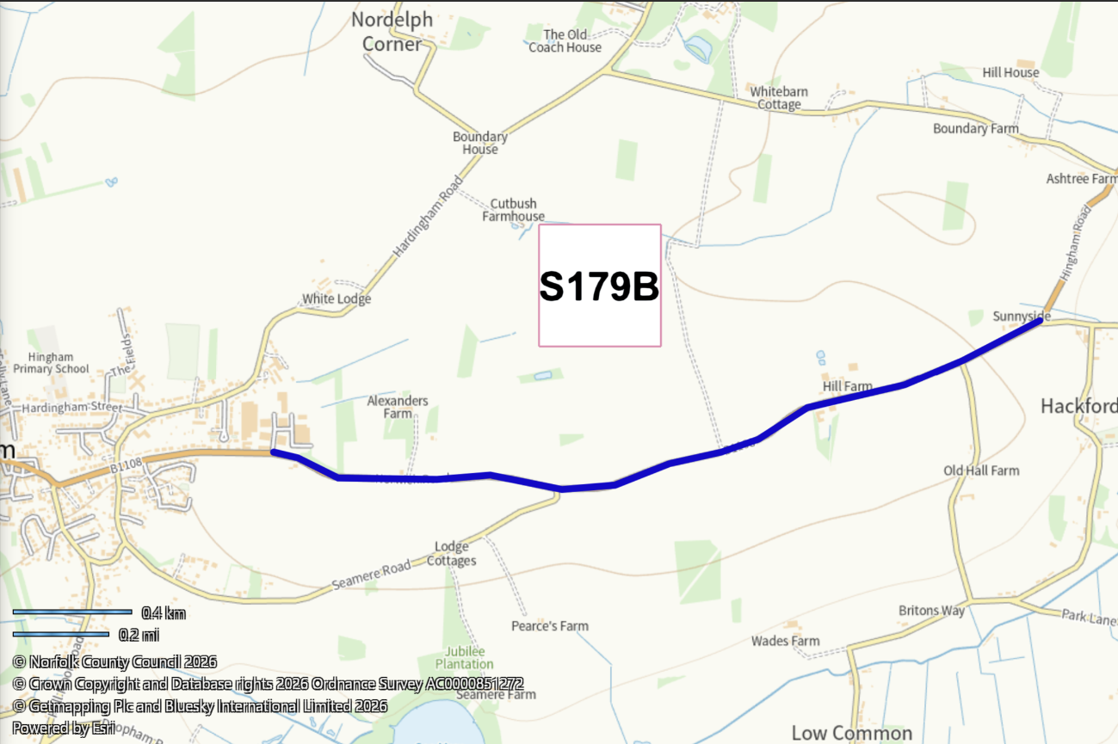

Road D, B1135 Crownthorpe Road
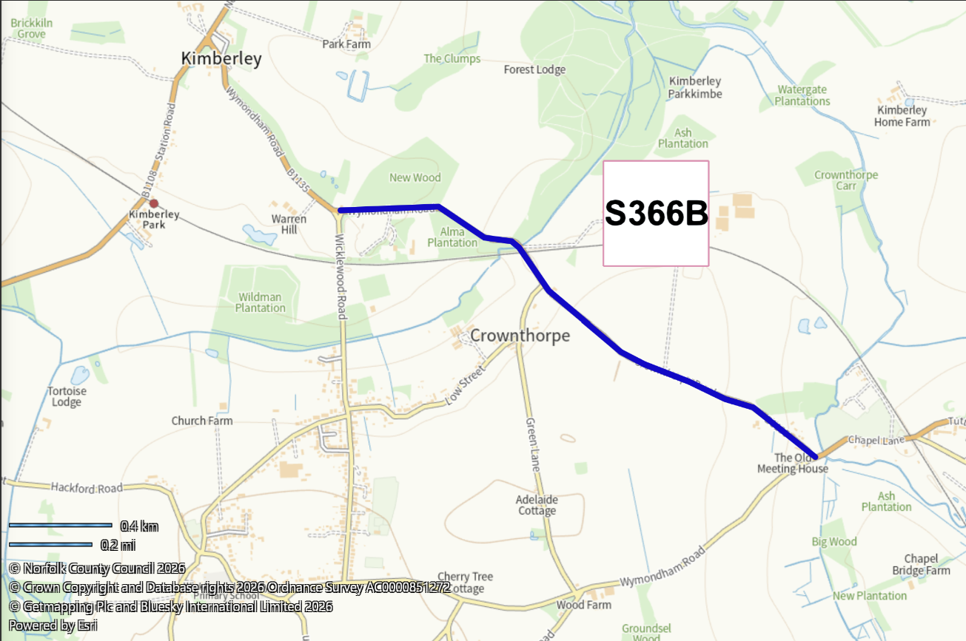

Road E, B1172 London Road
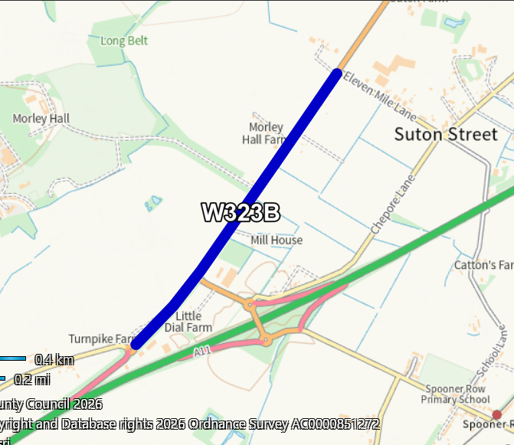

Road F, B1172 Station Road
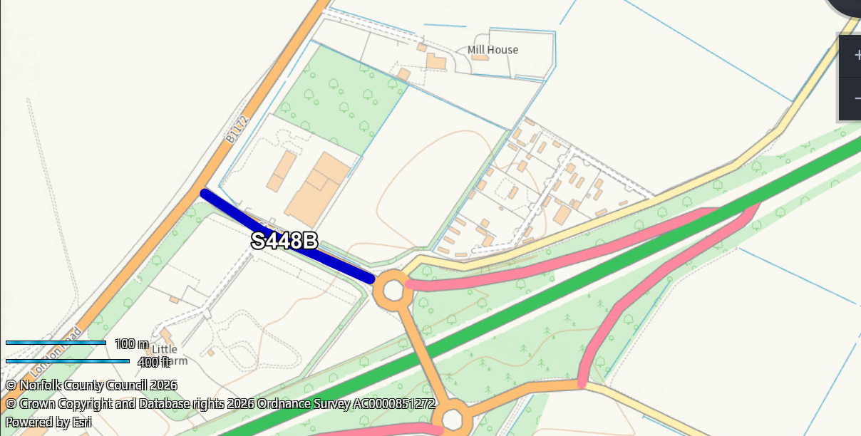

Road G, C489 Main Road
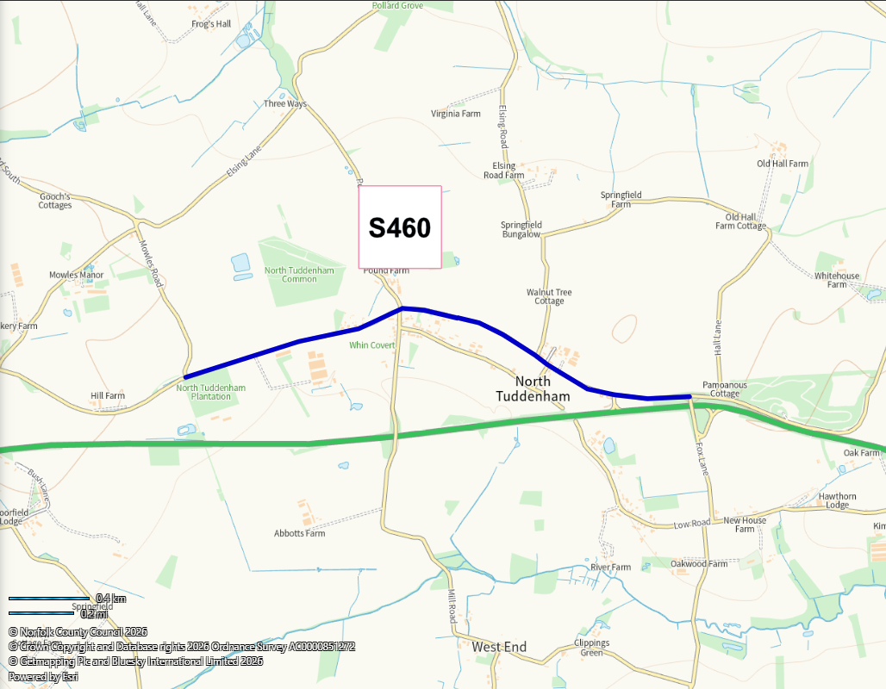

Road H, B1077 Attleborough Road
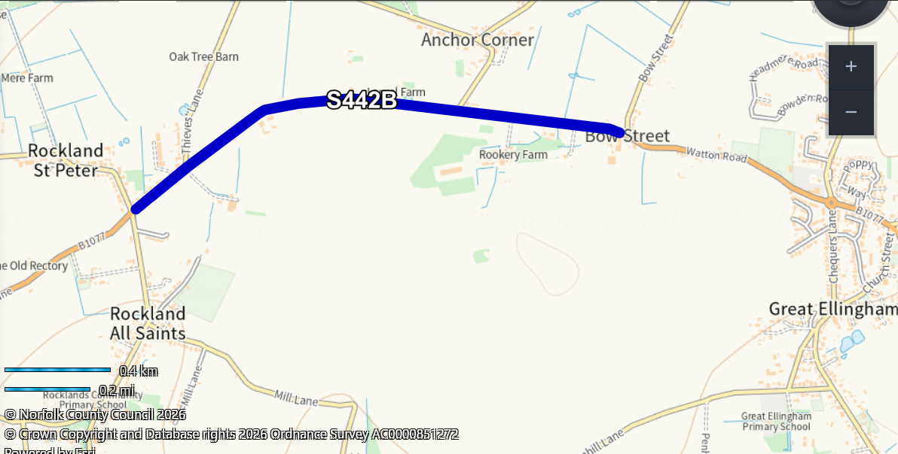

Road I, B1077 Buckenham Road
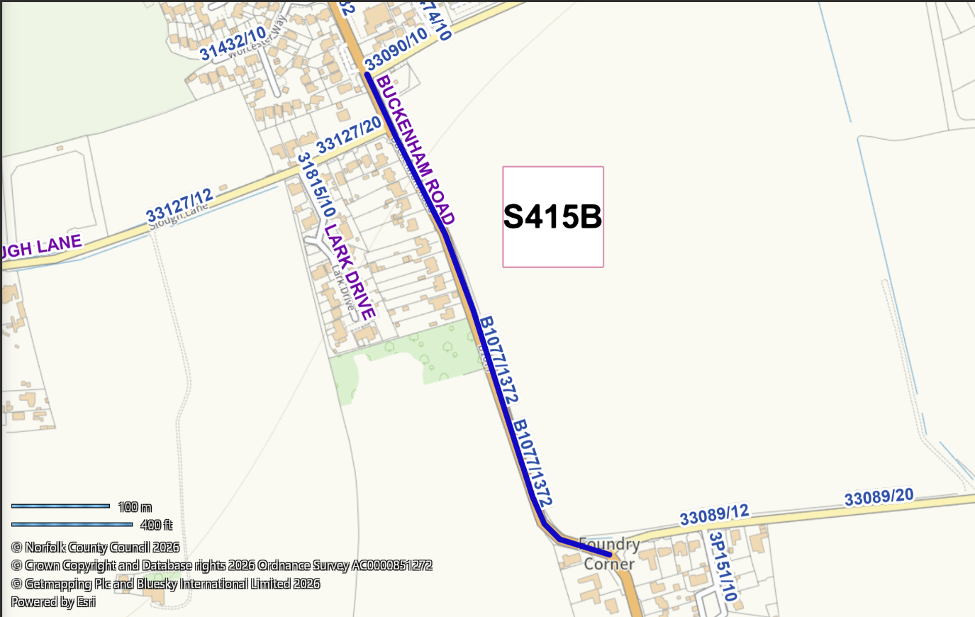

Road J, B1077 Attleborough Road
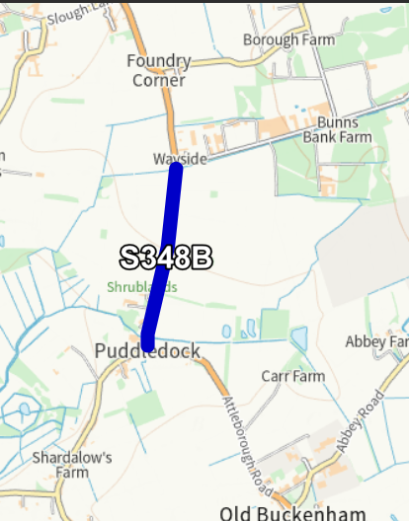

Road K, B1077 Haugh Road
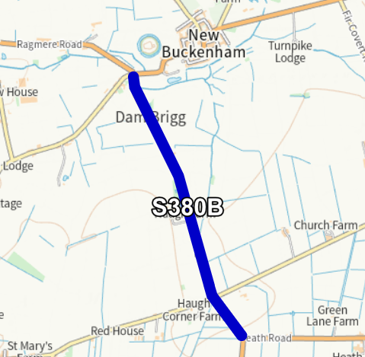

Road L, B1113 The Turnpike
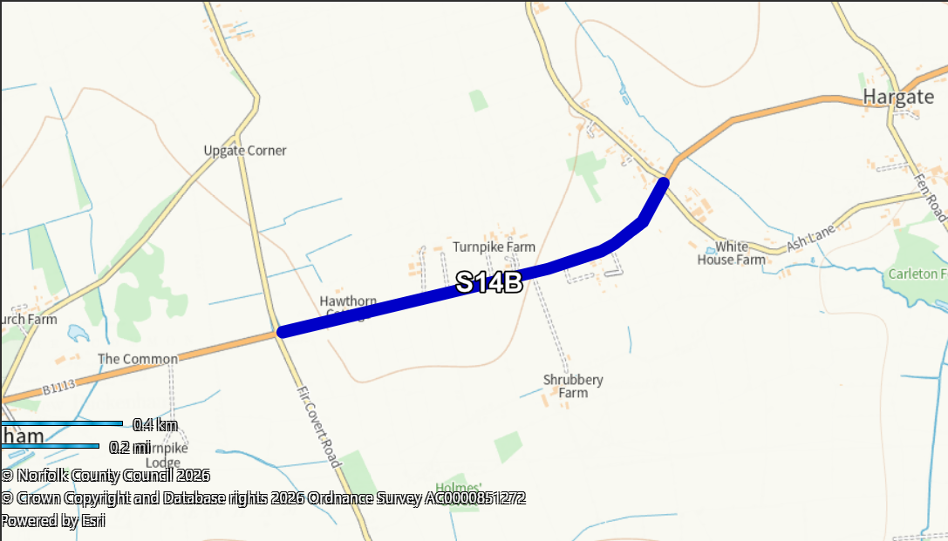

Road M, B1146 Draytonhall Lane
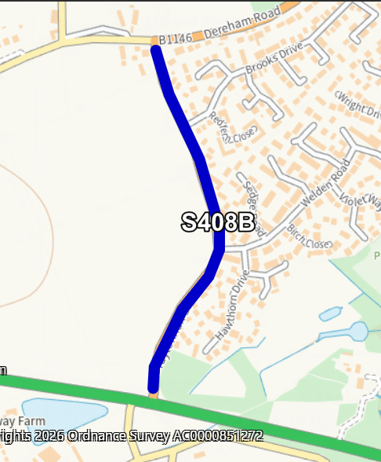

Road N, A1075 Shipdham Road, South Green
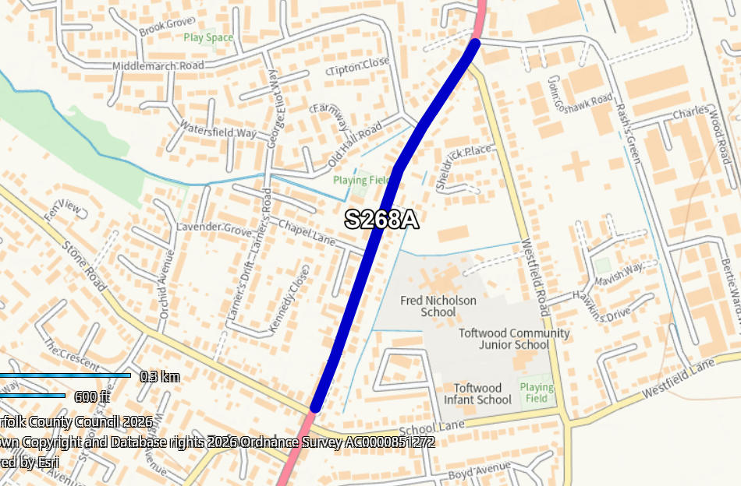

Road O, B1172 London Road
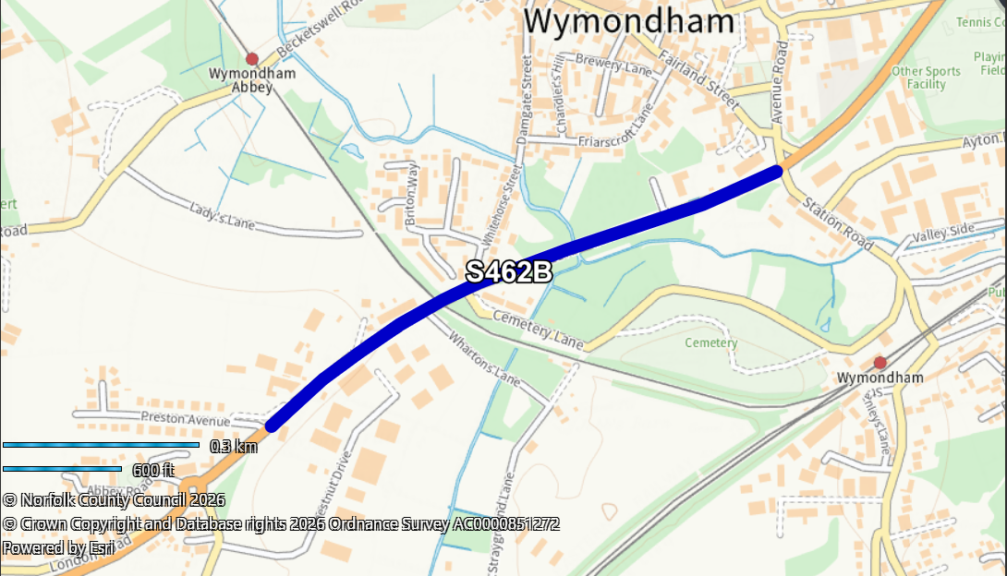

Road P, B1527 Hempnall Road and

Road Q, B1527 Mill Road
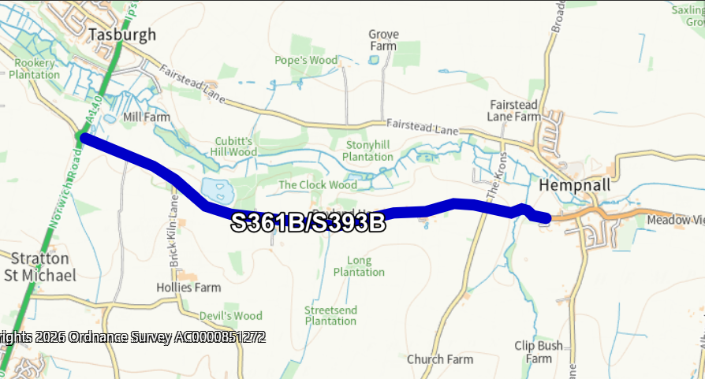

Road R, B1527 Bungay Road
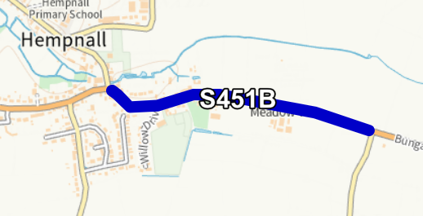

Road S, B1113 Norwich Road
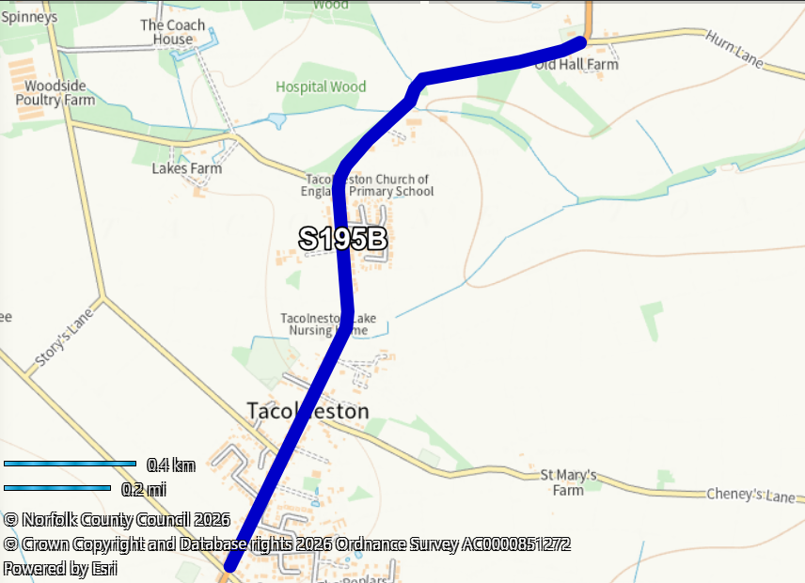

Road T, B1332 Norwich Road
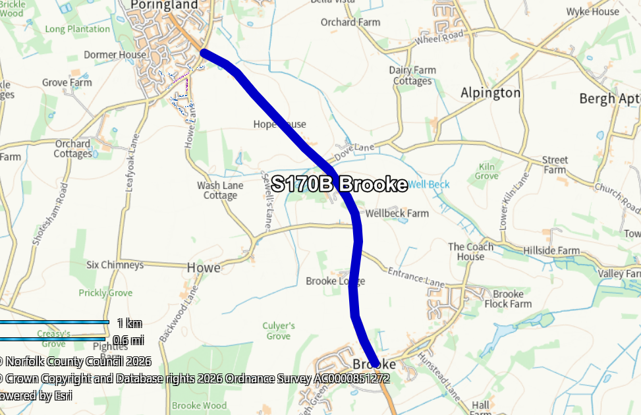

Road U, B1332 Norwich Road
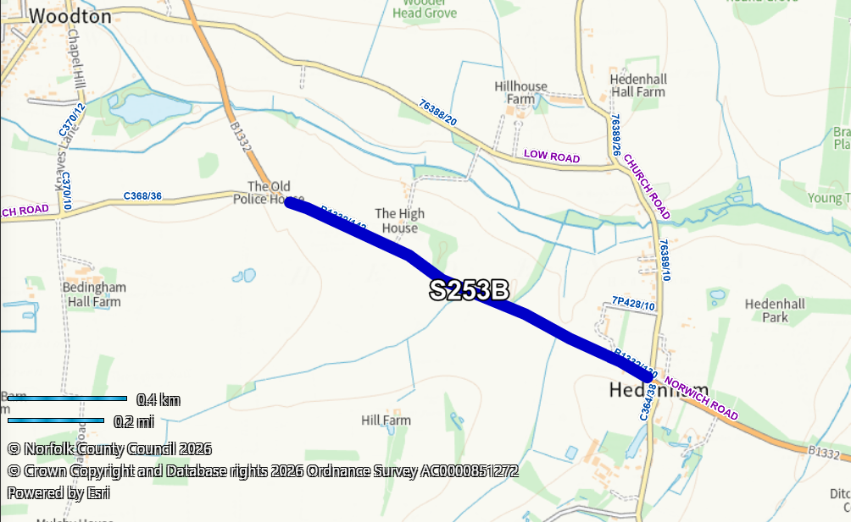

Road V, A143 Yarmouth Road
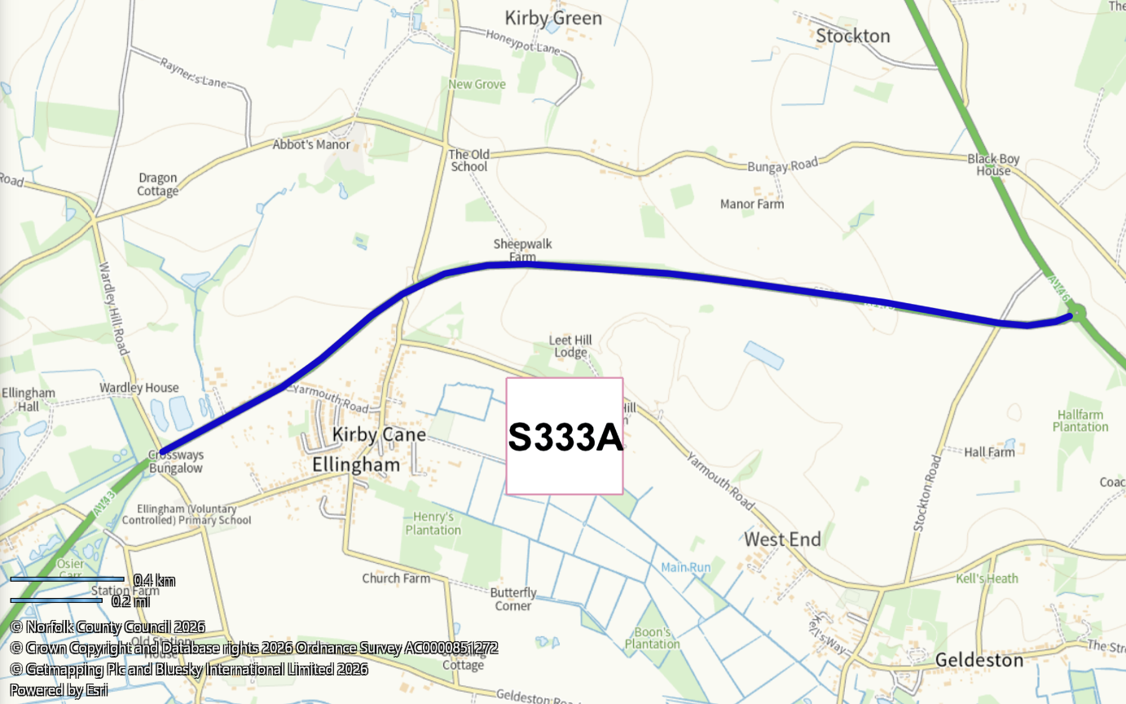

Road W, A1074 Dereham Road and

Road X, A1074 Dereham Road
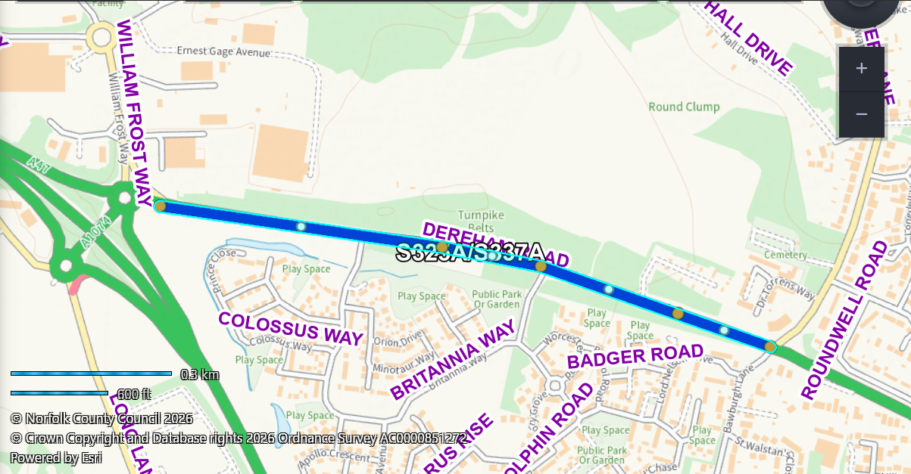

Road Y, A1075 Thetford Road, Memorial Way
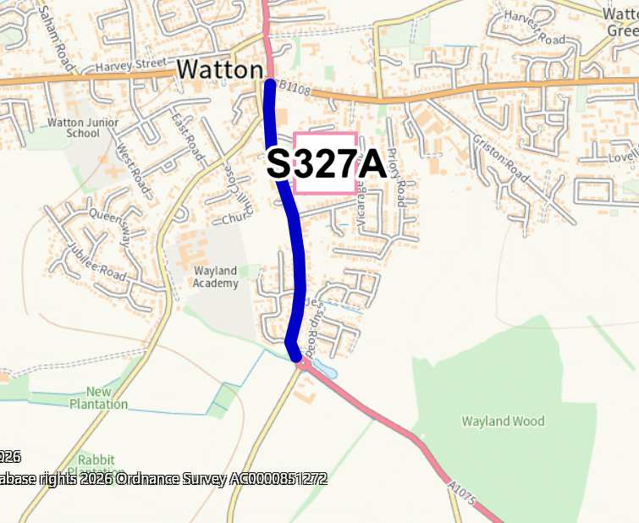

Road Z, A1066 Hurth Way
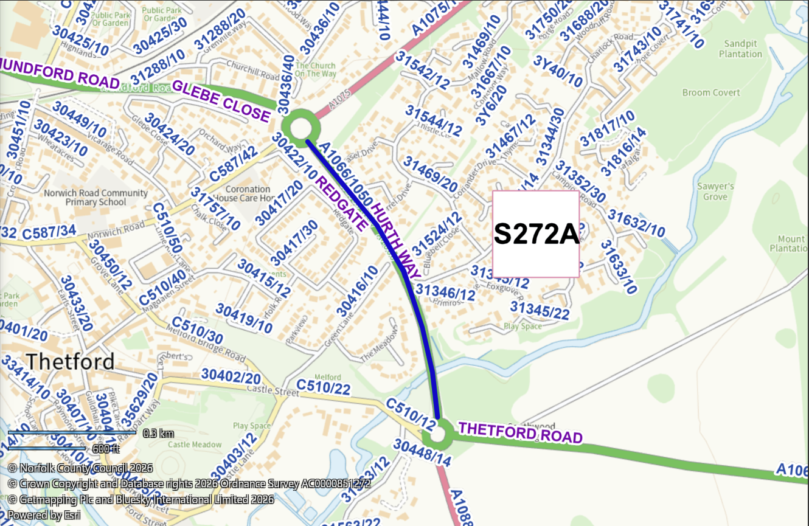

Road AA, C171 Norwich Road
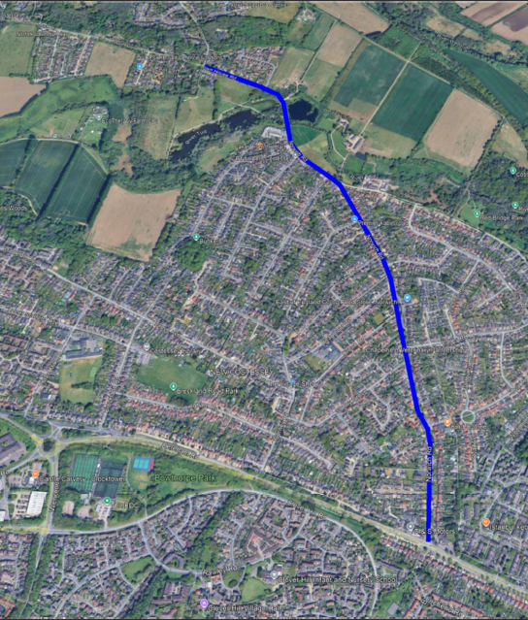

Road BB, C171 / C162 West End
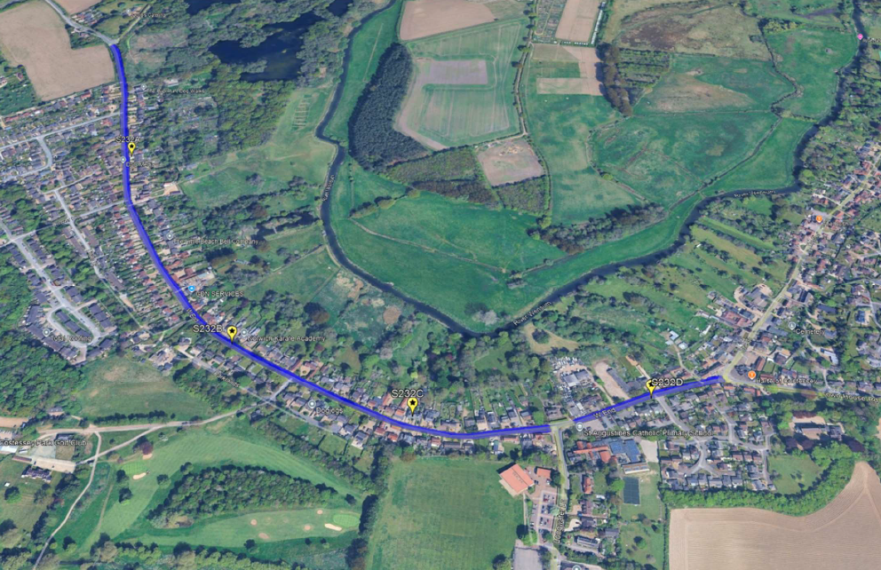

Road CC, C162 The Street
